**Boron doping into nanographite: A new way for controlling morphology**

Aaron Austin1, Elena Echeverria1, A. Kaan Kalka2, Linqi Zhang2, Lyndon Bastatas1, Armando G. McDonald3, and David N. Mcllroy1\*

1 Department of Physics, Oklahoma State University, Stillwater, OK 74078-3072 United States

2 School of Mechanical and Aerospace Engineering, Oklahoma State Universit, Stillwater, OK 74078, United States

3 Renewable Materials Program, Department of Forest, Rangeland and Fire Sciences, University of Idaho, Moscow, ID83844-1133, United States

Key words: Graphene; GUITAR; ortho-carborane; nanostructures

1. **ABSTRACT**

A newly synthesized carbon mesoscopic structure doped with boron has emerged via chemical vapor deposition. The new structures are dubbed Boron Ortho-carborane Doped (BOD) Carbon. The morphology of this structure is controllable with different concentrations of boron precursor in our solution and different growth times. Different techniques have been used to study and characterize the structure of this new material. Spectroscopic analysis with RAMAN and X-ray photoelectron (XPS) confirm boron content. Scanning Electron Microscopy (SEM) images show the different structures of this material and Transmission Electron Microscopy (TEM) has shown that these are not simply carbon nanotubes (CNT) because of graphitic structuring along the outer edge of the tubes. Further understanding the synthesis of this material is key to categorizing its specific properties and morphologies.

1. **INTRODUCTION**

The develop of new materials is follow by

1. **EXPERIMENTAL**

**Synthesis**

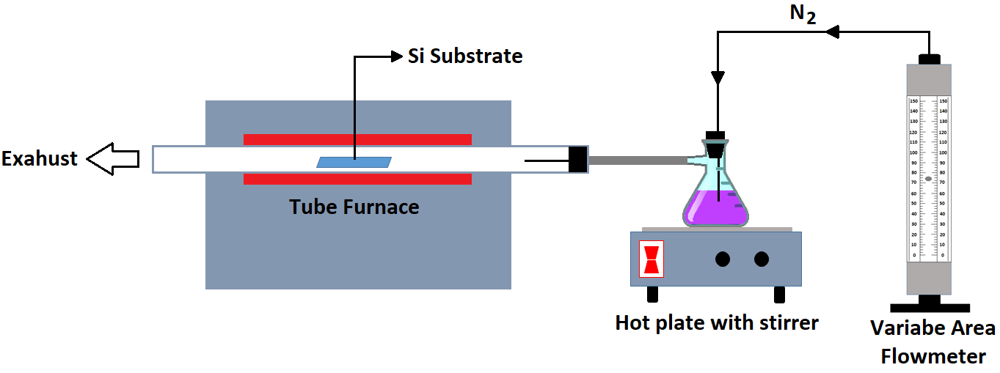

Figure 1. A schematic of the atmospheric pressure chemical vapor deposition system (APCVD)

A schematic of the system used to synthesize the boron ortho-carborane doped (BOD) carbon is shown in Figure 1. The system consists of a horizontal tubular furnace (Thermo Scientific Lindberg/Blue M), a quartz tube that serves as the reactor, a hot plate/stirrer (Corning), a bubbler and a variable area flowmeter. A silicon substrate previously cleaned by RCA is placed on a ceramic boat into the quartz tube at the hot zone of the furnace. The quartz tube is connected to the bubbler which contains both the boron and carbon precursors. The bubbler is attached to a variable area flowmeter which controls the flow of the carrier gas. Then, the atmospheric pressure chemical vapor deposition (APCVD) process is carried out by heating and magnetically stirring the solution inside the bubbler. A constant flow of N2 is used as the carrier and purge gas. After purging the system, the furnace is heated to 900 oC and solution to about 120 oC. Those temperatures are kept constants during the growth process.

Different amounts of ortho-carborane (Katchem) and sulphur (Fisher Scientific) were added to 100 mL 99 wt% cyclohexanol (Sigma Aldrich) to obtain different mesoscopic morphologies.

Deposition times from 10 min to 1 h were used for growing different samples. These deposition times were determined by the time during which samples were held at 900 °C after the deposition was started. The system was cleaned before each deposition, and different bubblers with different concentrations of the B precursor were used to avoid contamination and to have a better control of the boron.

**Characterization**

Scanning Electron Microscopy (SEM) micrographs were captured using an EI Quanta 600 field emission gun ESEM with Bruker EDS and HKL EBSD, the samples were mounted on the stage using double-sided carbon tape. The spot size resolution and voltage used were respectively, between 2-3 spot resolution and 10-15 kV. Transmission Electron Microscopy (TEM) micrographs were captured using a JEOL JEM-2100 with Bruker EDS. X-Ray photoelectron spectroscopy (XPS) was performed in an ultra-high vacuum system (UHV) with a base pressure 6.0 x 10-10 Torr. The XPS spectra were acquired using the Al-Kα emission line from a dual anode X-ray source (Physical Electronics XR 04-548) operated at 400 W and an incident angle of 54.7°. Ultraviolet photoelectron spectroscopy (UPS) spectra were acquired by using both the He I (21.2 eV) and He II (40.8 eV) excitation lines from a UVS 40A2 UV source (PREVAC). All spectra were collected at normal emission. While UPS spectra were acquired with both UV photon energies, for brevity, only data with 21.2 eV photon energy are discussed. The photoelectrons were collected and analyzed with an Omicrometer EA 125 hemispherical electron energy analyzer with a resolution of 20 meV. X-ray diffraction (XRD) data was acquired using a sixth generation MiniFlex benchtop X-ray diffractometer (Rigaku) and Raman Spectra were acquired using a Nicolet NXR 9610 FT-Raman Spectrometer at room temperature. The samples were excited by a semiconductor, 976 nm 1.2 W, laser source.

1. **RESULTS**

**Scanning Electron Microscopy (SEM)**

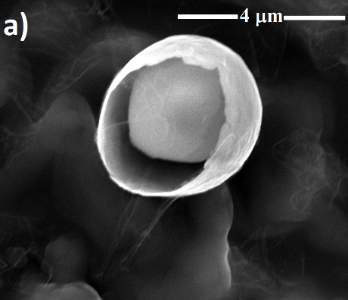 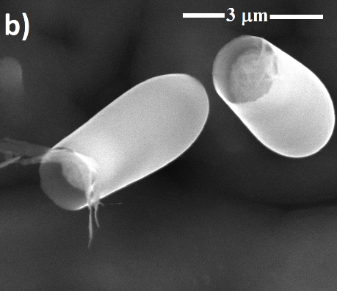 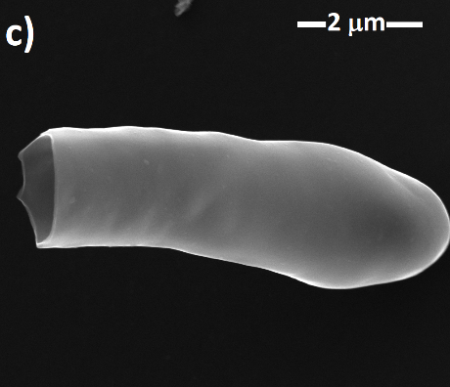 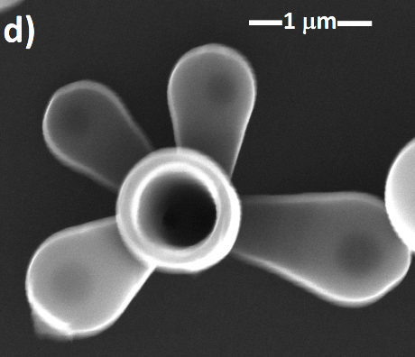 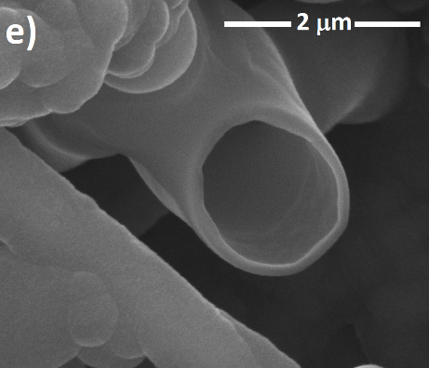 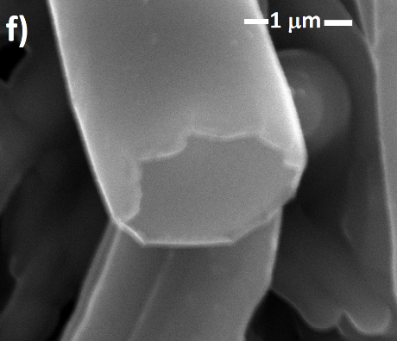 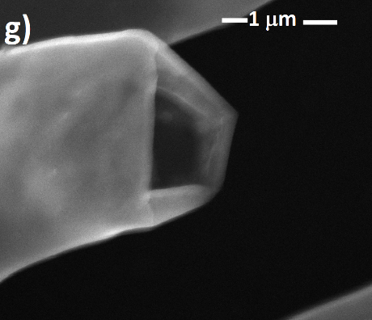 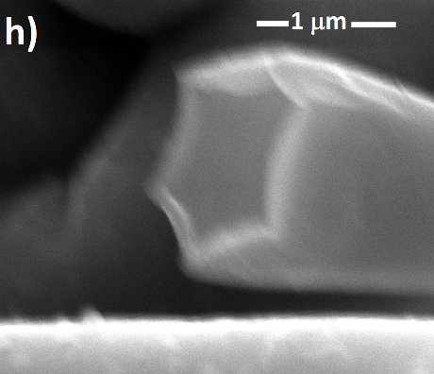 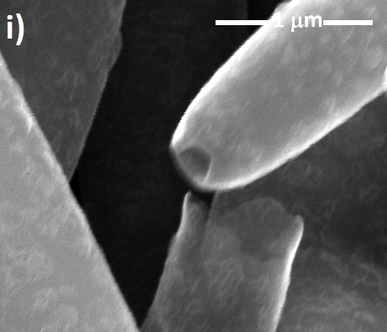

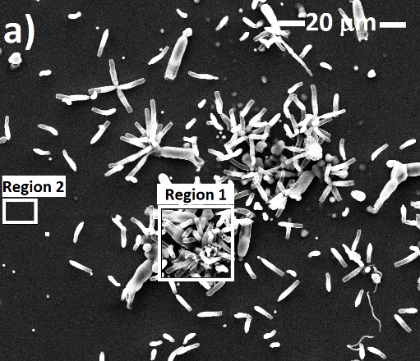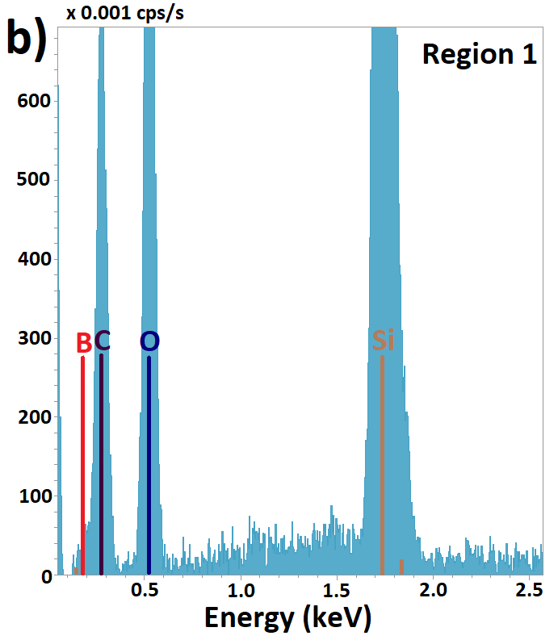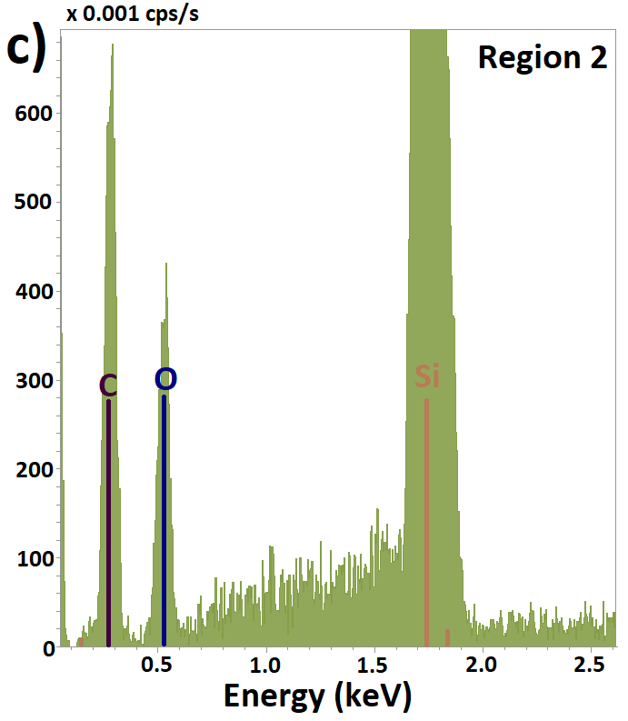

**XPS RESULTS**

For brevity, in the following discussion results from samples with the same amount of sulfur/cyclohexanol mix, and similar cooling times will be presented. Four samples will be discussed: 0 g, 3 g, 6 g and 12 g of B precursor. Only the sample with the highest amount of B content (12 g) presents the tubular structures mentioned before, as those shown in Figure 2b. Figure 6a shows the survey scans for each sample, for all of them C1s and O 1s peaks are clearly seen. Although, Boron is not easily seen in these scans, detailed scans (see Figure 6b) show the presence of boron. No signal from sulfur is seen in any of the studied samples. Atomic percentage for all samples are summarized in table 1. As the boron content increases, the binding energy of B1s shifts to high values, indicating the presence of boron oxycarbides BCO235,37,38 [ J Phys Chem C 2017 121 26034-26043].



  

Figure 6. XPS data for samples with different boron precursor concentration. a) Survey spectra, and core levels for b) B 1s and c) C 1s. d) Full width at half-maximum values for O 1s and C 1s with carbon content.

Table 1. Atomic concentrations for samples with different amount of boron precursor.

|  |  |  |  |  |  |  |
| --- | --- | --- | --- | --- | --- | --- |
| **Sample** | **C 1s (%)** | | **O 1s (%)** | | **B 1s (%)** | |
| 021218G 0 g o-c | 76.1 | 0.6 | 23.9 | 0.6 | - | - |
| 022418G 3 g o-c | 80.7 | 0.9 | 18.6 | 0.6 | 0.7 | 0.3 |
| 022718G 6 g o-c | 83.9 | 0.6 | 15.4 | 0.5 | 0.7 | 0.2 |
| 040719G 12 g o-c | 86.4 | 0.8 | 10.6 | 0.5 | 3.0 | 0.6 |

Figure 6c shows the C 1s core level spectra for all the studied samples. For pure GUITAR the sp2 C peak is at 284.6 eV, with B doping this peak shifts to lower binding energy, where the lowest value is at 284.0 eV for the highest B content studied (12 g). This shift in binding energy is due to C-B bonds formation37,39 [ref J. Phys. Chem C 2017 121 26034]. C 1s peak shows an asymmetric tail towards high binding energies, characteristic of samples with high concentrations of sp2 carbon40 [J. Mater. Chem 2012 22 390-395, J Phys Chem C 2017 121 26034-26043]. As the B content increases the peak at high binding energy that corresponds to C=O bonds (288.4 eV) is also decreasing, therefore, carbon oxidation due to thermal processes is reduced with B content. It can be also seen in table 1 that the atomic concentration for O is lower for the sample with highest B content compared to samples with lower boron precursor.

The full width at half-maximum (FWHM) values of O 1s and C 1s peaks as a function of B content are plotted in Figure 6d. From here, it is easily seen that B content decreases the FWHM for both carbon and oxygen, however, it is more notable for oxygen. Higher FWHM values means different species of that element within the sample, in this case those species are oxygen-related contaminants. These results are in agreement with the lower carbon oxidation obtained with high B content mentioned before. Decreasing of carbon oxidation has been proven before, where B doping is mainly used to protect C-C materials from oxidation28,38,41,42.

The plateau region in figure 6d, between 3 g and 6 g of the B precursor, is due to the fact that even though the amount on the B precursor was increased, the atomic concentration of B on both samples is similar, as shown in table 1. Therefore, not significant changes are expected for these two samples.

Valence band data was also collected for these samples. Both excitation lines were used, He I and He II, both showing similar results; therefore, only results for He I will be discussed.



Figure 7. Valence band spectra for samples with different boron precursor concentration. Inset: Expanded scale to show the region close to Fermi Level (EF).

Valence band for pure GUITAR (Figure 7, 0 g) shows a broad peak centered at ~ 8 eV. States at this binding energy are related to C 2p σ states. As the B is incorporated into the GUITAR structure, a second peak is seen at ~7 eV which is assigned to O 2p states (Figure 7, 6 g). At the highest B content, those two peaks are more pronounced and shifted (Figure 7, 12 g). Additionally, new density of states can be seen between 0 eV and 4 eV, as shown in the inset of Figure 7. This new feature is characteristic of the C 2p π bands. It is important to highlight that this sample also present the mesoscopic structures as those shown on Figure 2b. Therefore, the establishment of new C 2p π bands is directly related to the formation of these new structures, and it has also been related to B substitution on graphitic strcutrures39.

It is known that graphite-like materials are semi-metallic [ref …]. Here, the B content is altering the local density of states decreasing the band gap of the material, and making it more metallic. This behavior has been noticed before in CNT doped with boron [https://doi.org/10.1016/S0008-6223(02)00008-8], and the effect is attributed to the existence of BC3 islands within the carbon network.

For high concentrations of the boron precursor the mesoscopic structures were grown everywhere on the substrate, there is no evidence of scratches on the substrate where the structures were formed as needed for other type of nanostructures [carbon 1995 Yudasaka].

**XRD RESULTS**

The phase of the BODs compared to this of the GUITAR was examined by XRD measurements.



No significant differences in signal from GUITAR and BOD carbon samples were seen for angles higher than 30°. Graphite (002) peak in XRD is at around 26° and it is highly affected by intercalation43. The broad peak for GUITAR corresponds to multilayered graphene, this peak decreases with B inclusion, which represent either different spacing between layers, or more diamond-like behavior. Spectrum for GUITAR looks similar to that of a graphene paper (see CARBON 49 2011 2852), where the peak is really small compared to that of natural graphite sample. As the mesoscopic structures are formed, this peak decreases, we hypothesized that this is due to the fact that the mesoscopic structures are formed, the monolayer behavior is lost due to the formation of tubular structures



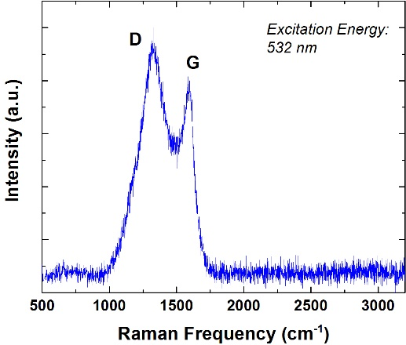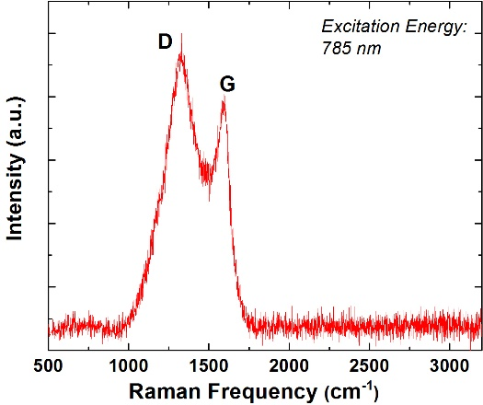

Figure XX: Raman spectrum for the BOD carbon

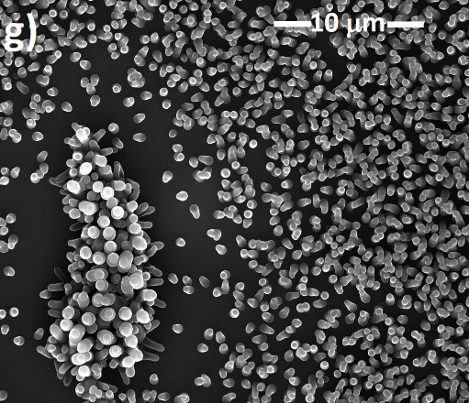

12 g o-c 40 min 12 o-c 20 min

The ensemble of BOD morphologies we have created here shows how the structure is affected by varying boron concentrations. Our results are depicted with SEM, TEM, and spectroscopic results and will be identified based on the amount of Ortho-Carborane and Sulphur in the solution. The deposition time is also considered in our results so that we may see the steps of growth over time.

**DISCUSSION**

The mesoscopic tubular structures presented in this work

B doping introduces stress in the structure of GUITAR, as a consequence the curvature of the GUITAR changes from being convex to concave relative to the substrate upon which they are grown. The stress is due to the position of the B on the lattice of the GUITAR. It is known that B substitution slightly deform layers on a highly oriented pyrolytic graphite (HOPG)44, what is surprising in this study is how the curvature of the GUITAR is completely inverted with B content, and consequently the creation of mesoscopic structures. Figure XX shows a schematic representation of the change in curvature in terms of the surfaces energies between solid and vapor (γSV) and solid and solid (γSS)45.

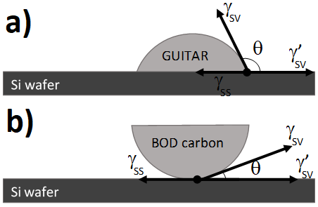

Figure XXX. Schematic representation of the surface tensions at the interface of the Si wafer and a) GUITAR, and b) BOD carbon structures.

In our configuration, there are three types of solids: the Si wafer,

It is known that substitutional boron in graphite-like structures lowers the rate of carbon gasification38, therefore decreasing the contact angle (θ) as shown in the figure XXX.

 

Enhance in energy capacities for LIBs are still required. “rechargeable lithium ion battery depends strongly on the structure of the anode materials” [Carbon 37 (1999) 561–568].

C:\Users\Elena\Documents\OSU\Guitar\SEM Images\030518G_Flake_35kx_006.tifC:\Users\Elena\Documents\OSU\Guitar\SEM Images\030518G_Flake_100kx_007.tif

C:\Users\Elena\Documents\OSU\BOD Proposal\20190911tem\05262018G_diff_003.tif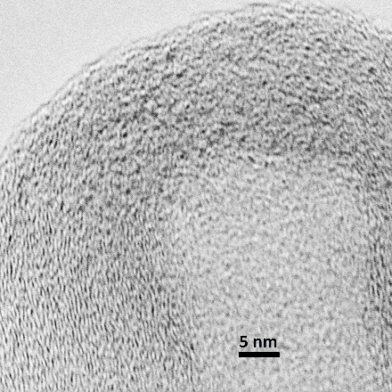

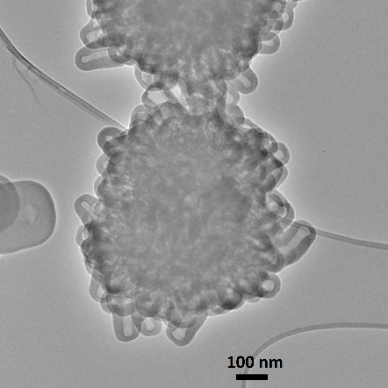 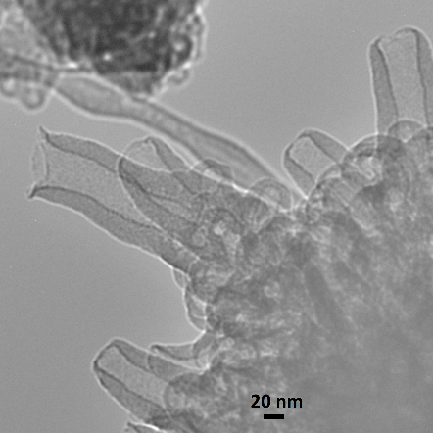

1. Cheng, I. F. *et al.* Synthesis of graphene paper from pyrolyzed asphalt. *Carbon* **49**, 2852–2861 (2011).

2. Cheng, I. F., Xie, Y., Gyan, I. O. & Nicholas, N. W. Highest measured anodic stability in aqueous solutions: graphenic electrodes from the thermolyzed asphalt reaction. *RSC Advances* **3**, 2379 (2013).

3. Gyan, I. O., Wojcik, P. M., Aston, D. E., McIlroy, D. N. & Cheng, I. F. A Study of the Electrochemical Properties of a New Graphitic Material: GUITAR. *ChemElectroChem* n/a-n/a (2015) doi:10.1002/celc.201402433.

4. Xie, Y. *et al.* Sulfur as an important co-factor in the formation of multilayer graphene in the thermolyzed asphalt reaction. *Journal of Materials Chemistry* **22**, 5723 (2012).

5. Kabir, H., Gyan, I., Foutch, J., Zhu, H. & Cheng, I. Application of GUITAR on the Negative Electrode of the Vanadium Redox Flow Battery: Improved V3+/2+ Heterogeneous Electron Transfer with Reduced Hydrogen Gassing. *C* **2**, 13 (2016).

6. Gyan, I. O. & Cheng, I. F. Electrochemical study of biologically relevant molecules at electrodes constructed from GUITAR, a new carbon allotrope. *Microchemical Journal* **122**, 39–44 (2015).

7. Kabir, H., Gyan, I. O. & Francis Cheng, I. Electrochemical modification of a pyrolytic graphite sheet for improved negative electrode performance in the vanadium redox flow battery. *Journal of Power Sources* **342**, 31–37 (2017).

8. Cao, Y. *et al.* Unconventional superconductivity in magic-angle graphene superlattices. *Nature* **556**, 43–50 (2018).

9. Zhang, W.-M., Wu, X.-L., Hu, J.-S., Guo, Y.-G. & Wan, L.-J. Carbon Coated Fe 3 O 4 Nanospindles as a Superior Anode Material for Lithium-Ion Batteries. *Adv. Funct. Mater.* **18**, 3941–3946 (2008).

10. Zheng, G., Yang, Y., Cha, J. J., Hong, S. S. & Cui, Y. Hollow Carbon Nanofiber-Encapsulated Sulfur Cathodes for High Specific Capacity Rechargeable Lithium Batteries. *Nano Lett.* **11**, 4462–4467 (2011).

11. Reddy, A. L. M., Shaijumon, M. M., Gowda, S. R. & Ajayan, P. M. Coaxial MnO 2 /Carbon Nanotube Array Electrodes for High-Performance Lithium Batteries. *Nano Lett.* **9**, 1002–1006 (2009).

12. Guo, J., Xu, Y. & Wang, C. Sulfur-Impregnated Disordered Carbon Nanotubes Cathode for Lithium–Sulfur Batteries. *Nano Lett.* **11**, 4288–4294 (2011).

13. Hu, Y.-S. *et al.* Synthesis of Hierarchically Porous Carbon Monoliths with Highly Ordered Microstructure and Their Application in Rechargeable Lithium Batteries with High-Rate Capability. *Adv. Funct. Mater.* **17**, 1873–1878 (2007).

14. Mao, M. *et al.* Pipe-Wire TiO 2 –Sn@Carbon Nanofibers Paper Anodes for Lithium and Sodium Ion Batteries. *Nano Lett.* **17**, 3830–3836 (2017).

15. Romanos, J. *et al.* Infrared study of boron–carbon chemical bonds in boron-doped activated carbon. *Carbon* **54**, 208–214 (2013).

16. Kroto, H. W., Heath, J. R., O’Brien, S. C., Curl, R. F. & Smalley, R. E. C60: Buckminsterfullerene. *Nature* **318**, 162–163 (1985).

17. Lu, X., Yu, M., Huang, H. & Ruoff, R. S. Tailoring graphite with the goal of achieving single sheets. *Nanotechnology* **10**, 269–272 (1999).

18. Baughman, R. H. Carbon Nanotubes--the Route Toward Applications. *Science* **297**, 787–792 (2002).

19. Novoselov, K. S. Electric Field Effect in Atomically Thin Carbon Films. *Science* **306**, 666–669 (2004).

20. Aurbach, D. A short review of failure mechanisms of lithium metal and lithiated graphite anodes in liquid electrolyte solutions. *Solid State Ionics* **148**, 405–416 (2002).

21. Dose, W. M. *et al.* Capacity fade in high energy silicon-graphite electrodes for lithium-ion batteries. *Chem. Commun.* **54**, 3586–3589 (2018).

22. Roberts, A. D., Li, X. & Zhang, H. Porous carbon spheres and monoliths: morphology control, pore size tuning and their applications as Li-ion battery anode materials. *Chem. Soc. Rev.* **43**, 4341–4356 (2014).

23. Ji, X., Lee, K. T. & Nazar, L. F. A highly ordered nanostructured carbon–sulphur cathode for lithium–sulphur batteries. *Nature Mater* **8**, 500–506 (2009).

24. Tang, K. *et al.* Hollow Carbon Nanospheres with Superior Rate Capability for Sodium-Based Batteries. *Adv. Energy Mater.* **2**, 873–877 (2012).

25. Wojcik, P. M. *et al.* Utilizing a Single Silica Nanospring as an Insulating Support to Characterize the Electrical Transport and Morphology of Nanocrystalline Graphite. *Materials* **12**, 3794 (2019).

26. *Graphene science handbook. Mechanical and chemical properties*. (CRC Press, Taylor & Francis Group, 2016).

27. Villarreal, C. C., Pham, T., Ramnani, P. & Mulchandani, A. Carbon allotropes as sensors for environmental monitoring. *Current Opinion in Electrochemistry* **3**, 106–113 (2017).

28. Radovic, L. R., Karra, M., Skokova, K. & Thrower, P. A. The role of substitutional boron in carbon oxidation. *Carbon* **36**, 1841–1854 (1998).

29. Panchakarla, L. S., Govindaraj, A. & Rao, C. N. R. Boron- and nitrogen-doped carbon nanotubes and graphene. *Inorganica Chimica Acta* **363**, 4163–4174 (2010).

30. Ayala, P., Arenal, R., Rümmeli, M., Rubio, A. & Pichler, T. The doping of carbon nanotubes with nitrogen and their potential applications. *Carbon* **48**, 575–586 (2010).

31. Stephan, O. *et al.* Doping Graphitic and Carbon Nanotube Structures with Boron and Nitrogen. *Science* **266**, 1683–1685 (1994).

32. Ma, J., Guan, S. & Lai, C.-H. Disorder effect on electronic and optical properties of doped carbon nanotubes. *Phys. Rev. B* **74**, 205401 (2006).

33. Sharifi, T. *et al.* Nitrogen doped multi walled carbon nanotubes produced by CVD-correlating XPS and Raman spectroscopy for the study of nitrogen inclusion. *Carbon* **50**, 3535–3541 (2012).

34. Yudasaka, M., Kikuchi, R., Ohki, Y. & Yoshimura, S. Nitrogen-containing carbon nanotube growth from Ni phthalocyanine by chemical vapor deposition. *Carbon* **35**, 195–201 (1997).

35. Kim, C., Fujino, T., Hayashi, T., Endo, M. & Dresselhaus, M. S. Structural and Electrochemical Properties of Pristine and B-Doped Materials for the Anode of Li-Ion Secondary Batteries. *J. Electrochem. Soc.* **147**, 1265 (2000).

36. Yudasaka, M. *et al.* Specific conditions for Ni catalyzed carbon nanotube growth by chemical vapor deposition. *Appl. Phys. Lett.* **67**, 2477–2479 (1995).

37. Sheng, Z.-H., Gao, H.-L., Bao, W.-J., Wang, F.-B. & Xia, X.-H. Synthesis of boron doped graphene for oxygen reduction reaction in fuel cells. *J. Mater. Chem.* **22**, 390–395 (2012).

38. Allardice, D. J. & Walker, P. L. The effect of substitutional boron on the kinetics of the carbon-oxygen reaction. *Carbon* **8**, 375–385 (1970).

39. Kim, Y. A. *et al.* Raman Spectroscopy of Boron-Doped Single-Layer Graphene. *ACS Nano* **6**, 6293–6300 (2012).

40. XPS Interpretation of Carbon. https://xpssimplified.com/elements/carbon.php.

41. Ehrburger, P., Baranne, P. & Lahaye, J. Inhibition of the oxidation of carboncarbon composite by boron oxide. *Carbon* **24**, 495–499 (1986).

42. Jones, L. E. & Thrower, P. A. Influence of boron on carbon fiber microstructure, physical properties, and oxidation behavior. *Carbon* **29**, 251–269 (1991).

43. Prasad, B. L. V. *et al.* Intercalated nanographite: Structure and electronic properties. *Phys. Rev. B* **64**, 235407 (2001).

44. Endo, M., Hayashi, T., Hong, S.-H., Enoki, T. & Dresselhaus, M. S. Scanning tunneling microscope study of boron-doped highly oriented pyrolytic graphite. *Journal of Applied Physics* **90**, 5670–5674 (2001).

45. McIlroy, D. N. *et al.* Nanospring formation—unexpected catalyst mediated growth. *J. Phys.: Condens. Matter* **16**, R415–R440 (2004).